DATA ANALYSIS INTERNSHIP – DAY 10 REPORT
Organization: Top Tech Developers
Topic Covered: Matplotlib and its Functions
On Day 10 of the internship, various graph creation techniques and visualization functions were practiced using Matplotlib in Google Colab. Different types of graphs were created to understand data representation, comparison, and analysis. Matplotlib helps in converting numerical data into visual format for easier interpretation.

Introduction
Matplotlib is a widely used Python library for data visualization. It allows users to create graphs, charts, and plots for analyzing datasets effectively. During this session, different plotting functions and customization techniques were practiced.
Import Statement
import matplotlib.pyplot as plt
Explanation
- matplotlib → Main visualization library
- pyplot → Module used for plotting graphs
- plt → Alias name used for easy access

1. Common Matplotlib Functions
The following plotting functions were practiced during the session:
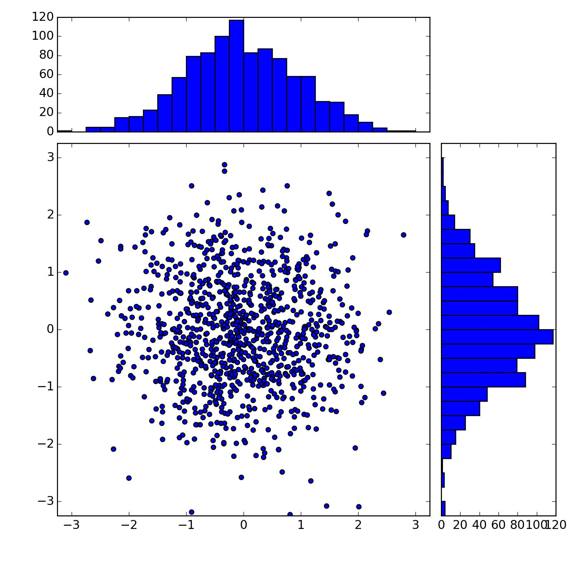
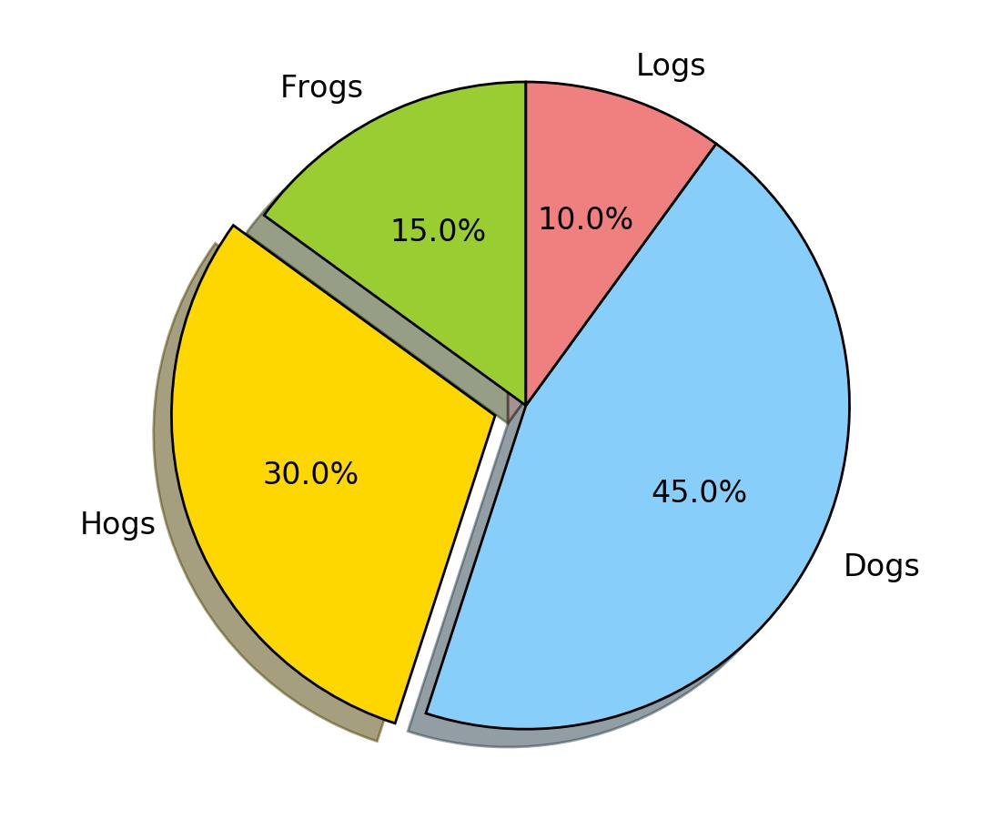
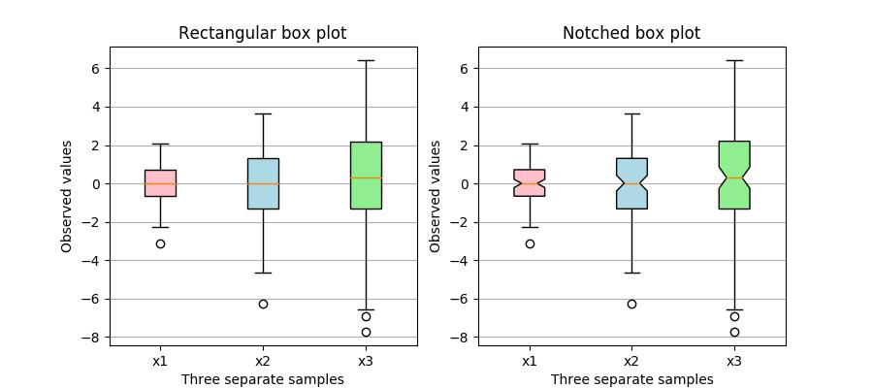
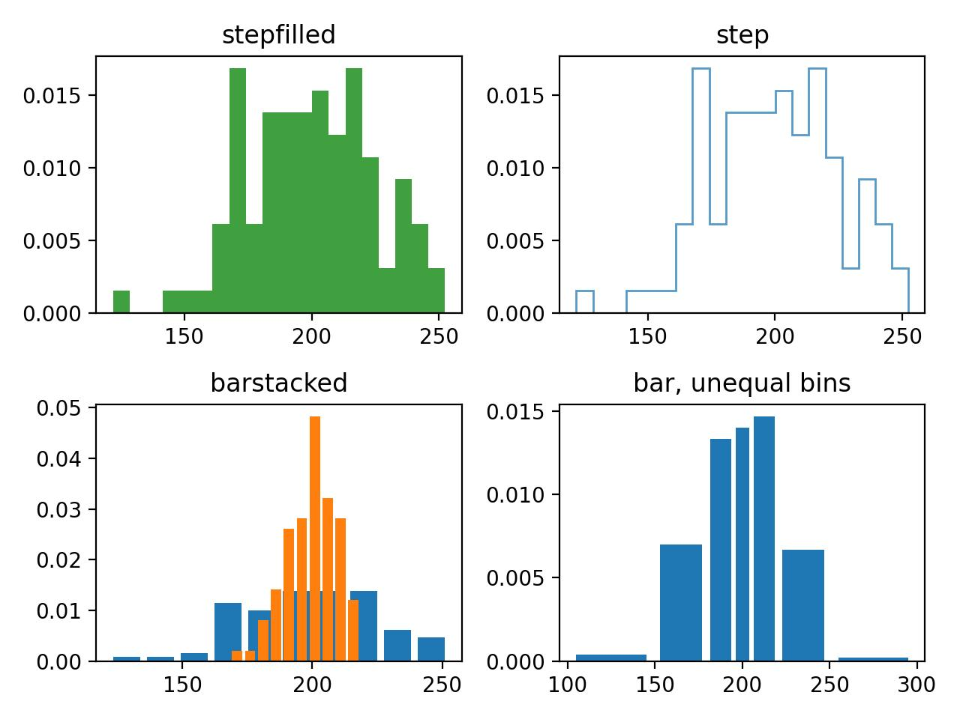
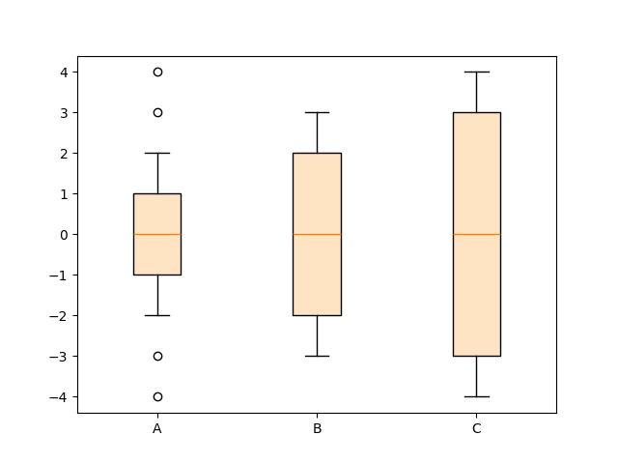
1. Line Graph Function
Function: plt.plot()
Used to create line graphs.
Example:
plt.plot(x, y)

2. Bar Chart Function
Function: plt.bar()
Used to create bar charts.
Example:
plt.bar(x, y)

3. Scatter Plot Function
Function: plt.scatter()
Used to create scatter plots.
Example:
plt.scatter(x, y)

4. Histogram Function
Function: plt.hist()
Used to display frequency distribution.
Example:
plt.hist(data)

5. Pie Chart Function
Function: plt.pie()
Used to create pie charts.
Example:
plt.pie(values)

6. Box Plot Function
Function: plt.boxplot()
Used to represent data distribution.
Example:
plt.boxplot(data)

7. Area Plot Function
Function: plt.fill_between()
Used to create area plots.
Example:
plt.fill_between(x, y)

2. Functions Used for Graph Customization
Graph customization functions were used to improve graph appearance and readability.
Functions Practiced
- plt.xlabel() → Used to set x-axis label
- plt.ylabel() → Used to set y-axis label
- plt.title() → Used to add graph title
- plt.legend() → Used to display labels
- plt.grid() → Used to add grid lines
- plt.show() → Used to display the graph
- plt.figure() → Used to adjust graph size
- plt.subplot() → Used to create multiple graphs in one figure
- plt.xlim() → Used to set x-axis range
- plt.ylim() → Used to set y-axis range
- plt.style.use() → Used to apply graph styles

3. Usage of Matplotlib
Matplotlib is commonly used in the following areas:
- Data Visualization
- Data Comparison
- Statistical Analysis
- Trend Analysis
- Report Generation
- Machine Learning Visualization
- Graphical Representation of Datasets
Observation
- Graphs make numerical data easier to understand.
- Visualization helps identify trends and comparisons quickly.

4. Practical Graphs Created
During the session, the following graphs were created using Matplotlib:
- Line Graph
- Bar Graph
- Scatter Plot
- Histogram
- Pie Chart
- Box Plot
- Area Plot
Purpose
- To compare numerical values
- To identify patterns in datasets
- To understand frequency distributions
- To represent percentages visually

Technologies Used
- Python
- Matplotlib
- Google Colab
- Data Visualization
- Data Analysis

Learning Outcome
On Day 10, I learned how to create different graphs and customize them using Matplotlib.
I understood:
- how to create line graphs, bar charts, scatter plots, histograms, and pie charts
- how to use box plots and area plots
- how to add titles, labels, and legends
- how to adjust graph size and styles
- how visualization supports data analysis
- how graphs help in identifying trends and patterns

Conclusion
The Day 10 internship session helped me understand the practical use of Matplotlib for data visualization. I practiced different plotting functions such as line graphs, bar charts, scatter plots, histograms, pie charts, box plots, and area plots.
Additionally, I learned graph customization techniques such as adding labels, titles, legends, grid lines, and adjusting figure size. This session improved my understanding of graphical representation and how visualization is used in data analysis and machine learning.

